Dear Parents,
I hope you and your family are keeping well. I am providing a guideline of work your child may complete over the coming week. As always, there is absolutely no pressure to complete tasks given. “Remember, we are learning in the things we do at home with our families, not just in books but in Life Experience.”
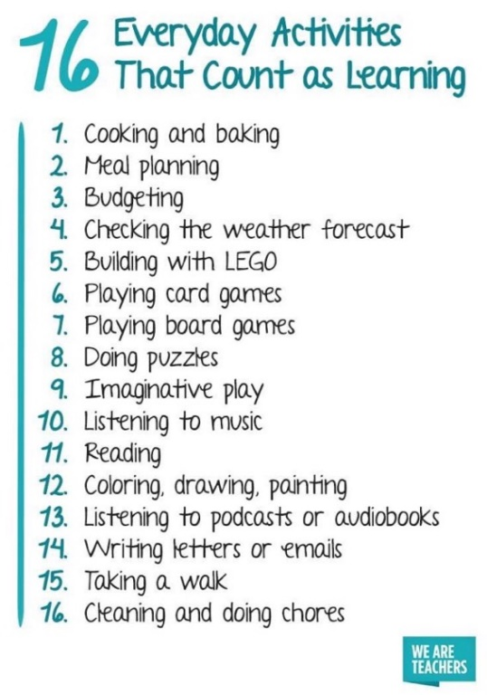
Well done to all the boys and girls who made a fantastic effort on Seesaw last week. I have to say I am thoroughly enjoying this new experience. It’s great to be able to see you all and hear that you are having such fun at home with your families. The standard of work from the children and the efforts from you as parents in aiding your children must be commended. I thank you all for your support. I will continue to put up activities each day. This is the Seesaw timetable for the week so as the children are aware what topics will be posted each day.
Monday | Tuesday | Wednesday | Thursday | Friday
English-My Weekend (oral and writing) | English- Reading strategy (Visualizing) | English- Reading Strategy (Determining Importance) | English Grammar- there/their/they’re | English- Poetry
Maths- spatial Awareness | Maths (addition with regrouping) | Maths (addition with regrouping) | Maths (addition with regrouping) | Maths (addition with regrouping)
Gaeilge- Ag imirt rugbaí | Gaeilge- Ag imirt rugbaí | Gaeilge- Ag imirt rugbaí | Gaeilge- Ag imirt rugbaí | P.E.
Science- Spring | History- Tractors | Geography- Mexico | Art | Music- Tin whistle playing

*Please note this is open to change
If you have not contacted me already about an access code for Seesaw, please do so at mskenneallysnc@gmail.com
Thanking you again for your support,
Frances Kenneally.

English
Spell Well- Week 30 (revision pages) pages 62 and 63
Two Little Frogs-Read one story each day and answer the questions orally or else you can write them if you wish
Unit 19 Why Zebras have Stripes
Unit 20 Rumplestiltskin
Unit 21 The Lion with the Smelly Breath
Unit 22 Three Naughty Ostriches
Unit 23 The Biggest Fish
Two Little Frogs- Phonics ck an p k t d sounds Pages 30,34,38
Grammar their/there and of/off Pages 35 and 39
Handwriting Book- continue with your handwriting book
English in Practice- Unit 12 (pages 57 to 61)
Gaeilge
Our theme again this week is Caitheamh Aimsire (pastimes) Ag imirt rugbaí(playing rugby)
Abair Liom book pages108-111
Folens Book Publishers are giving access to all digital resources for the Abair Liom Irish programme. For access go to http://FolensOnline.ie and click register, select Teacher, fill in a username, email and password. For Roll Number use the code Prim20.
Once logged in, go to search and type in ag imirt rugbaí, then click on the second box, Póstaer and you will find lots of activities based on this week's theme. Some of the options are as follows Cuardach (search), Foclóir(vocabulary), Ceisteanna (questions), Amhrán (song) and Dán (song). The children use this website in school on a daily basis so they should be well able to do the activities.
Before starting any of the activities the children should go over the following words.
The following are the words/ vocabulary that the children will use over the coming week. Please click on the link below.
Flashcards Irish - caitheamh aimsire (pastimes)
This week we will move on to the Dán (poem) based on this theme and also the Comhrá (conversation) as well as revising what we covered last week.

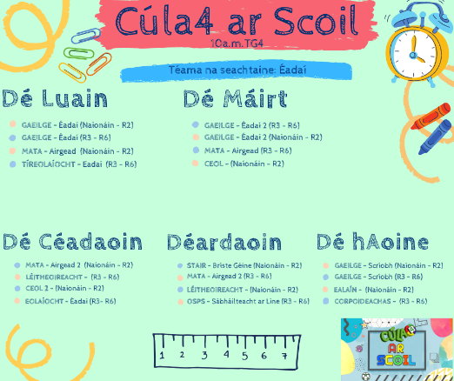
Join Cúla4 ar Scoil Monday to Friday from 10am on TG4. Lessons from the programmes are available on YouTube Cúla4 and catch-up with programmes you've missed on Cúla4.com The theme this week on Cúla4 ar Scoil is 'Clothes'. Múinteoir Caitríona will teach the different types of clothes. The parts of the programme (Naíonáin-R2) (Juniors to second class) may be of interest to your child.

Maths
Tables Champion- Week 26
Tables- start subtraction tables on page 4 of Tables Champion -3
Cracking Maths- I am aware that children don't have their textbook at present so for now use the online version of the book below and the children can write their answers on a sheet/ in a copy etc.
Children can complete an activity based on Spatial Awareness Page 139 Cracking Maths (between/ under/ around/ on top of/ to the right of etc.)
We will start regrouping on Tuesday on Seesaw. This will be our main focus this week. Pages 132 to 138 (Cracking Maths)

https://www.gillexplore.ie/gill-explore-resources/cracking-maths-1st-class-pupils-book

History
The Farm (Tractors)- Small World Page 58
Geography
Mexico- Small World Pages 64 and 65 Go to Kid’s World Travel Guide to find out lots of interesting facts about Mexico
https://www.kids-world-travel-guide.com/mexico-facts.html
Science
Small World page 62- spring
Music
Practice the new note high d
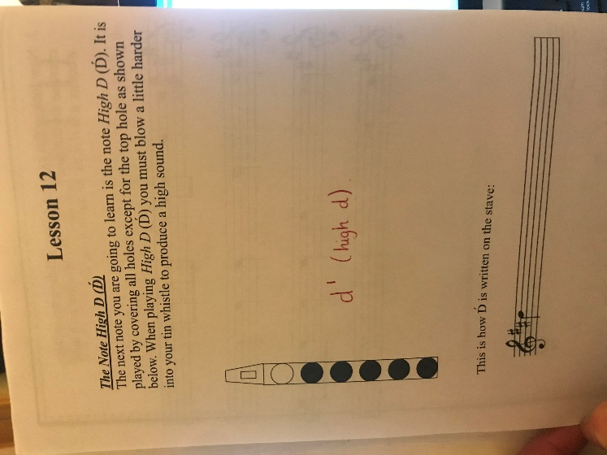
Also why not try the new tune below:
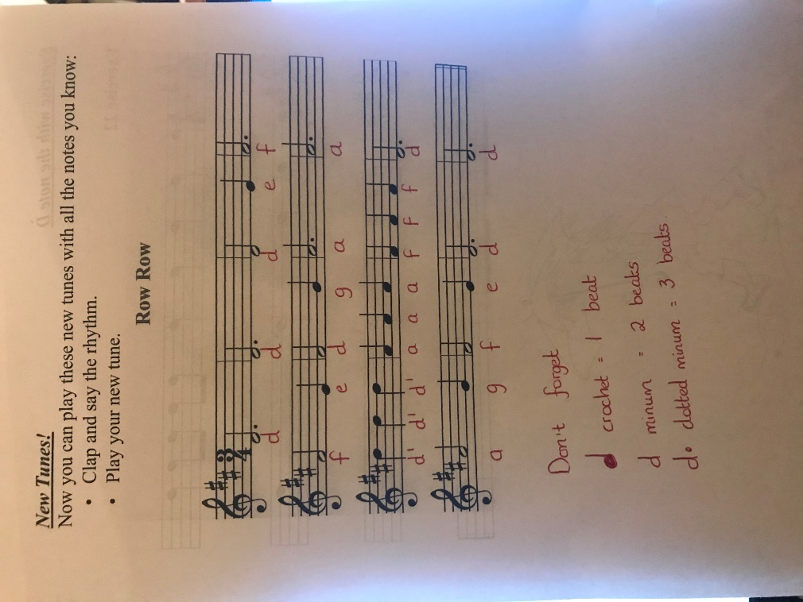

PE
National ‘Active SCHOOL Week’ takes place every April and is a really enjoyable part of the school year for many children.
This year, because of COVID-19, it is not possible for this to go ahead so we are asking you to participate in the ‘Active HOME Week‘ challenge instead. We are encouraging all children to be extra active at home this week. There are some brilliant ideas for sports, games and activities included on the Active Schools website.
https://activeschoolflag.ie/
Once you click on the link above, click on Active Home Week .You can then click on challenge charts, Ideas word Cloud, Resources etc. You can fill in the Challenge Chart each day and return it to me via Seesaw or email at the end of the week. If you do any of these activities then please send me some photos so that I can put them on the school website and Twitter.

